**Title**

On the utility of predicting stroke rates from accelerometers using captive otariids

**Running title**

Predicting stroke rates from accelerometers

**Authors**

Monique A. Ladds1*, David A. Rosen2, David J. Slip1,3, and Robert G. Harcourt1

1Marine Predator Research Group, Department of Biological Sciences, Macquarie University, North Ryde, NSW Australia 2113

2Marine Mammal Research Unit, Department of Zoology, University of British Columbia, Vancouver, BA Canada

3Taronga Conservation Society Australia, Bradley's Head Road, Mosman, NSW Australia 2088

*Author for correspondence ([monique.ladds@hdr.mq.edu.au](mailto:monique.ladds@hdr.mq.edu.au); ph: +61298507980; fax: +61298507972)

**Key words**

**Abstract**

**Introduction**

Measuring the energy expenditure of free living pinnipeds is an important but difficult task. Numerous approaches, such as heart rate (Boyd *et al.* 1999), doubly labelled water (DLW) (Jeanniard-du-Dot *et al.* 2016a) and overall dynamic body acceleration (ODBA) (Fahlman *et al.* 2013) have been tried and tested with mixed results. Among other things the predictive equations for each of these can change with species, size of the animal, activity type, temperature, or digestive state (Fish 2000, Ladds *et al.* 2016, Rosen *et al.* 2016). Therefore, there is unlikely to ever be a universal method, or equation for that method, that can accurately estimate energy expenditure for pinnipeds. [Thus, moving forward the focus should be on the simpler, less invasive methods that can still provide a good estimate of energy expenditure]. Stroke rate is a relatively non-invasive method that has shown potential to measure energy expenditure in Northern fur seals (XXX) (Jeanniard-du-Dot *et al.* 2016b) and Weddell seals (XXX) (Williams *et al.* 2004). Movement in water, where pinnipeds hunt for food, requires the use of large fore-flippers, or the lateral movement of hind flippers to propel. As this is where most work expends from, it is assumed that counting flipper strokes can be used as a proxy for energy expenditure.

Before estimates of energy expenditure can be made from stroke rate we must know if we can accurately estimate stroke rates from accelerometers. Pinnipeds perform long and deep dives while hunting, meaning that they are difficult to observe. Hence biologists tend to rely on biotelemetry devices to provide insights on the location, physiology, and behaviour of otariids while at sea. Accelerometers have been successfully used to estimate stroke rates from a number of marine animals. Therefore, counting flipper strokes may provide an alternative measure of energy expenditure for otariids. Cameras have been used to identify strokes for phocids, dolphins and whales (Williams *et al.* 2000), but these are expensive, heavy and only have enough memory and battery to record bouts of diving, rather than whole foraging trips. Accelerometers have validated to estimate total stroke number for Weddell seals diving from ice-holes with cameras attached to the animals (Williams *et al.* 2004). They have also been used to estimate stroke rate for Northern fur seals (Jeanniard-du-Dot *et al.* 2016b), though this has not been validated.

Estimating stroke frequency from accelerometers assumes that the peaks in the outputs correspond to a stroke. Phocids stroke with their rear flippers with a lateral sway, therefore it is assumed that the peaks in the sway axis (y axis) correspond to a stroke. Otariids use large fore-flippers to propel forward, therefore the peaks in the surge (x axis), heave (z axis) or both (Jeanniard-du-Dot *et al.* 2016b) axes are used to estimate strokes. The peak in lateral sway was confirmed for Weddell seals using animal-borne cameras (Williams *et al.* 2004), but there is yet to be a validation study for otariids. When using accelerometers to measure proxies, the choice of running mean influences the overall estimate (Shepard *et al.* 2008). Estimating strokes from accelerometers requires appropriate smoothing of data and the choice of a minimum gradient to determine a peak in the data. The choice of these two parameters will influence the overall estimate, thus should be tested across a range of values. Therefore, we evaluated the best parameters for calculating stroke rate for otariids swimming underwater.

**Materials and Methods**

*Animals*

We conducted experiments between October and December 2014 at two research facilities: Underwater World (RF2: Mooloolaba, QLD, Australia) and Taronga Zoo (RF3: Sydney, NSW, Australia) with three New Zealand fur seals, two Australian fur seals and four Australian sea lions that were on permanent display at their respective marine facilities. We conducted experiments in November and December 2015 at the Open Water Research Station (RF4: Port Moody, BC, Canada) with four Steller sea lions housed for research purposes (see Table 1 for details of the animals). All animals were non-reproductive during the study period and were cared for under the husbandry guidelines of the individual facility. All the Australian sea lions were born as a part of a captive breeding program ongoing in Australian aquaria, while all the fur seals came into captivity as juveniles having been found in poor health or injured and were considered unsuitable for release back into the wild after prolonged rehabilitation. All animals were in good health and condition as assessed by the in-house veterinary surgeon at the time of the experiments. All Steller sea lions were collected from breeding rookeries as pups and raised in captivity at the Vancouver Aquarium (British Columbia, Canada). Macquarie University ethics committee (ARA-2012_064) and Taronga ethics committee (4c/10/13) approved experiments conducted in Australia. All animal handling and experimental procedures in Canada were conducted in accordance with regulations of the Canadian Council on Animal Care (University of British Columbia animal use permit #A11-0397), Department of Fisheries and Oceans Canada (MML 2007-001) and the Vancouver Aquarium.

*Trial protocol*

During all experiments otariids were equipped with a 3-axis accelerometer (RF1-3: CEFAS G6a+, ±8g, 40 × 28 × 16.3 mm and mass 18 g in air and 4.3 g in seawater, CEFAS technology Ltd, Lowestoft, UK; RF4: Daily Diary, 95 × 45 × 26 mm, 90 g, Wildlife Computers; Table 1.) and were also recorded with static underwater cameras. All sea lions (except ASM2) wore a tight-fitting harness containing the accelerometer while all fur seals (and ASM2) had the accelerometer attached with tape. Sea lions at RF4 were previously trained to swim underwater between two submerged feeding stations (Rosen *et al.* 2016) while otariids at RF1-3 were trained to swim laps of a pool between two stationary targets. All animals were familiar with the experimental equipment and performed all trials voluntarily under trainer control.

*Stroke rate estimation*

Accelerometers (described above) recorded time, depth, and acceleration on 3 axes: anterior-posterior (surge), lateral (sway) and dorso-ventral (heave), from which separate diving and resting ODBA and VeDBA values, plus the stroke rate from trials, were extracted. Video footage from RF2, RF3 and RF4 was pseudo-randomly collected with 10 animals participating in other experiments (Ladds *et al.* 2016) from which we could directly count stroke rate. Underwater swimming at RF2-3 was recorded with GoPro HERO3 (GoPro, USA) mounted inside PVC pipes each with a viewing window cut-out that were placed in the pool during trials (see Hocking *et al.* 2015 for a figure of the set up). Sea lions at RF4 had the GoPro mounted to their harness and oriented towards the pectoral flipper. Videos were downloaded and edited together in Adobe Premiere Pro (Adobe Systems Incorporated, California), before being exported at the same frame rate as the accelerometer recorded (i.e., G6a+ 25 FPS and 25Hz at RF1-3; Daily Diary 32 FPS and 32 Hz at RF4). Accelerometer data was matched with the corresponding frame rate on the video which allowed us to extract data for dives and resting periods.

The dynamic acceleration was then used to predict stroke rate, where strokes were identified as peaks in the x axis (see Fig. 1, and description below). Actual total stroke number for a trial was counted from videos of individual trials. Strokes that used a single flipper or that were only below the body were not included as they were often masked on the accelerometry by other movement. The running mean used and the gradient of the peak affected the overall ability of the peaks to predict total stroke rate, therefore a combination of these variables was created and tested for their ability to predict total strokes for a dive.

*Statistical analysis*

Stroke rate was estimated from peaks in the dynamic acceleration of the x, z and x + z axes. Peaks were extracted from the accelerometry data based on a minimum gradient before a peak. Since both the running mean and the minimum gradient of the peaks influenced the overall stroke rate estimate, combinations of these were created. The running means tested were 0.4, 1, 2, 3 and 4 seconds and the gradients tested were 10, 20, 30, 40 and 50 (Fig. 2) for otariids with the accelerometer taped on and 60, 70, 80, 90 and 100 for otariids with the accelerometer in a harness. The gradients differed for the two groups as the accelerometers were recording at different Hz; higher Hz resulted in more noise in the data which required a higher gradient. The best stroke rate prediction was defined as the running mean and gradient that resulted in the fewest errors when compared to observed stroke rates (Fig. 3). This was determined by testing if the differences were significantly different from 0 using a one-sample Z-test. All analysis was completed in R (Version 3.1.3; R Core Development Team 2015) and values are reported as mean ± SD.

**Table 1. Seal characteristics and summary metabolic rates from all trials.** Species, ID, mass (kg), age (years) and marine facility where housed, type of accelerometer used, recording rate and method of attachment for five fur seals and eight sea lions. Marine facility: RF2 – Underwater World; RF3 – Taronga Zoo; RF4 – Open Water Research Station. *Indicates otariids identified as subadults during trials.

|  |  |  |  |  |  |  |  |
| --- | --- | --- | --- | --- | --- | --- | --- |
| Species | ID | Mass | Age | Marine | Device | Recording | Attachment |
|  |  |  |  | **facility** |  | **rate** | **method** |
| Australian fur seal | AFF1 | 69-78 | 17 | RF2 | G6a+ | 25Hz | Tape |
| AFM1 | 179-182 | 14 | RF2 | G6a+ | 25Hz | Tape |
| Australian sea lion | ASM1 | 153-160 | 12 | RF3 | G6a+ | 25Hz | Tape |
| New Zealand fur seal | NFM1* | 54-55 | 8 | RF3 | G6a+ | 25Hz | Tape |
| NFM2 | 149-161 | 11 | RF2 | G6a+ | 25Hz | Tape |
| NFM3 | 154 | 13 | RF3 | G6a+ | 25Hz | Tape |
| Steller sea lion | F00BO | 155-160 | 15 | RF4 | Daily Diary | 32Hz | Harness |
| F97HA | 172-175 | 18 | RF4 | Daily Diary | 32Hz | Harness |
| F97SI | 230-233 | 18 | RF4 | Daily Diary | 32Hz | Harness |
| F00YA | 214-218 | 15 | RF4 | Daily Diary | 32Hz | Harness |

**Results**

*Predicting stroke rates*

We tested 25 different combinations of minimum gradient before peak (tape: 10-50; harness: 60-100) and running means (0.1-4 sec) to smooth data. A larger gradient was required for the otariids wearing harnesses because of the noise generated from the higher sampling rate of the accelerometer (32 Hz vs 25 Hz) and movement from the harness. We evaluated the difference between predicted stroke rate and actual stroke rate. Stroke rate could be accurately predicted from finding peaks in the dynamic acceleration of the x, z and x + z axes, and the accuracy of this prediction was dependent on the gradient and running mean used. There were some differences in the prediction accuracies of depending on the axis or combination of axes used, but these differed depending on the combination of the running mean and gradient. Individuals required a different combination of running mean and gradient to achieve the lowest error rates for stroke prediction (Table 2).

When looking at the output for the harness group, there was no consistent results for the choice of axis, running mean or gradient. Generally, a higher gradient (>70) and a higher running mean (>2 seconds) resulted in lower errors (Appendix B). Z-tests revealed that eight of the 25 running mean and gradient combinations were not significantly different from 0.

Figure 3 displays the distribution of errors for some selected combinations of gradients and running means. Distributions centred on 0 with small variances represent the best combinations of running mean which differed for each animal group. The best combination was chosen from the distribution that was not significantly different from 0. For otariids with the harness, the best combination was a running mean of 1 second and a gradient of 100 (Fig. 3A). For otariids with the accelerometer taped the best combination was a running mean of 4 seconds and a gradient of 30 (Fig. 3B).

*Energy expenditure from stroke rates*

Figure X. demonstrates the expected loss or gain in estimated energy expenditure from calculating stroke frequency using different gradients using a running mean of three seconds. Figure X.D is the estimated energy from the running mean and gradient combination with the fewest errors. Here, the error is centred around 0, meaning that although on some dives the total number of strokes may be over- or under- estimated, but over a long foraging trip these errors will be controlled. However, if a different gradient is chosen, then the total number of strokes for a dive, and hence the energy expenditure for that dive, is generally underestimated. Using a conservative value of 50kJ underestimated on each dive on a foraging trip of 1000 dives could result in a 50MJ difference for that trip.

Excess energy expenditure = ± 50kJ × 1000 dives = ± 50,000 kJ ~ 50 MJ



**Table 2. Summary of the combination of running mean and gradient that best predicts stroke rate from the dynamic X-axis, along with the sum and average of the difference between the predicted number of strokes for that combination and number of trials for five fur seals and five sea lions.** *Indicates otariids identified as subadults during trials.

|  |  |  |  |  |  |  |  |  |  |  |  |  |  |  |  |
| --- | --- | --- | --- | --- | --- | --- | --- | --- | --- | --- | --- | --- | --- | --- | --- |
| Species | ID | Method | N | Best running | | | Best | | | Average | | | Difference | | |
|  |  |  |  | **mean (secs)** | | | **gradient** | | | **difference** | | | **%** | | |
|  |  |  |  | **X** | **Z** | **XZ** | **X** | **Z** | **XZ** | **X** | **Z** | **XZ** | **X** | **Z** | **XZ** |
| Australian fur seal | AFF1 | Tape | 12 | 4 | 0.4 | 0.4 | 40 | 40 | 40 | 0.17 | 0.08 | 0.58 | -3.65 | 0.52 | 1.92 |
| AFM1 | Tape | 19 | 0.4 | 0.4 | 0.4 | 50 | 50 | 50 | 3.11 | 2.26 | 2.58 | -7.10 | -5.69 | -6.70 |
| Australian sea lion | ASM1 | Tape | 17 | 4 | 4 | 3 | 30 | 40 | 40 | 2.24 | 0.35 | 1.00 | -5.02 | -2.83 | -1.56 |
| New Zealand  fur seal | NFM1m | Tape | 12 | 0.4 | 4 | 4 | 40 | 50 | 50 | 0.50 | 0.17 | 0.08 | -2.06 | -1.32 | -1.45 |
| NFM2s | Tape | 19 | 0.4 | 1 | 1 | 50 | 50 | 50 | 2.68 | 0.43 | 1.47 | -2.15 | -1.02 | -2.64 |
| NFM3* | Tape | 7 | 1 | 1 | 0.4 | 40 | 40 | 40 | 0.00 | 0.43 | 0.00 | -0.26 | -5.84 | -2.64 |
| Steller sea lion | F00BO | Harness | 14 | 3 | 4 | 2 | 90 | 90 | 80 | 0.07 | 0.07 | 0.15 | -1.01 | -0.82 | -1.63 |
| F97HA | Harness | 7 | 2 | 4 | 4 | 60 | 70 | 70 | 1.0 | 0.86 | 0.14 | -3.19 | 8.64 | 2.48 |
| F97SI | Harness | 9 | 2 | 2 | 2 | 100 | 90 | 90 | 0.56 | 0.56 | 0.56 | 2.70 | 1.01 | 8.26 |
| F00YA | Harness | 19 | 2 | 1 | 1 | 100 | 60 | 60 | 0.16 | 0.05 | 0.47 | 4.37 | 2.02 | 4.96 |

**Discussion**

Choosing the correct combination of running mean and gradient to predict stroke rate is important because total number of strokes could be under- or over- predicted by 20%.

Captive animals are often used as proxies of what we would expect to see in the wild. But with limited space and constant access to humans it is often difficult to assume that they accurately represent what we expect to see in the wild.

On a typical foraging trip, adult fur seals and sea lions perform thousands of dives. Using a conservative estimate of 1500 dives over a foraging trip we estimated that energy expenditure could be over- or under- estimated by 75MJ. Considering that other otariids have been measured to expend less than 30 MJ per day this amount of error is undesirable.

For animals that had the accelerometer taped on, using just the z-axis to predict strokes was better than using X or X+Z. While the prediction differences were relatively small, over a long foraging trip this could result in errors of up to XX, which when converted into energy could be the difference between XX and XX Kj.

A relationship between stroke rates determined by accelerometers and energy expenditure estimated with doubly labelled water (DLW) was found for Northern fur seals (Jeanniard-du-Dot *et al.* 2016b).

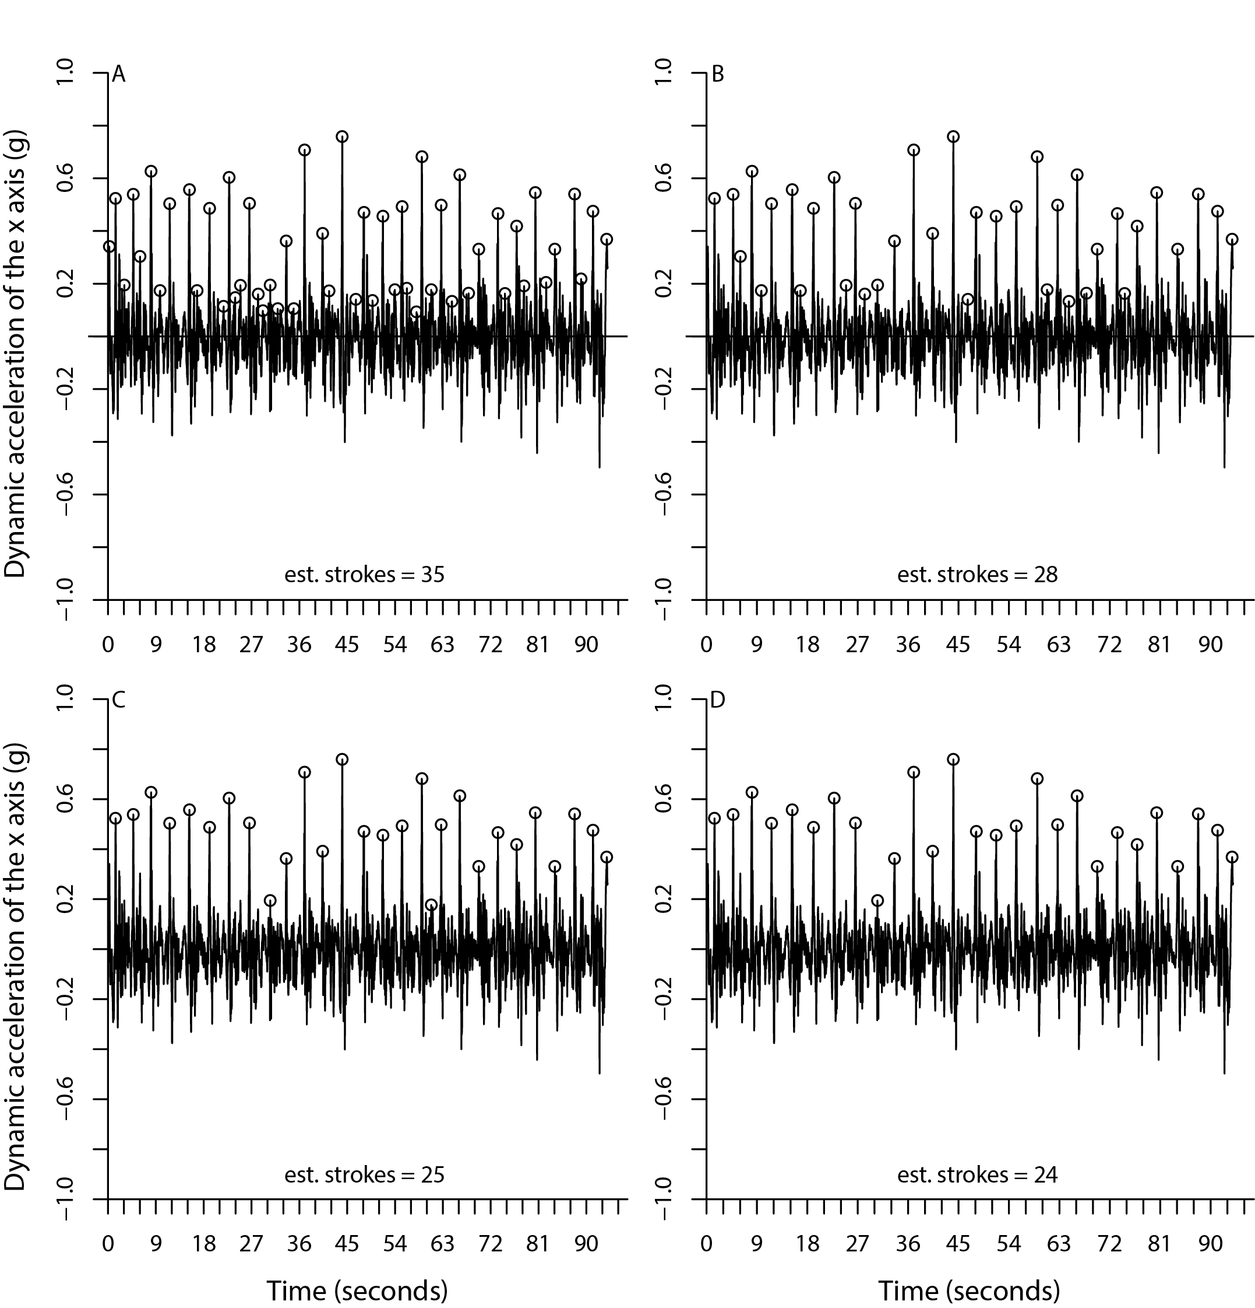

**Figure 1. Dynamic acceleration of the x axis from a running mean of 1 second with different gradients applied to find peaks.** A – gradient = 10; B - gradient = 20; C - gradient = 30; D - gradient = 40. Actual number of strokes for this sample (as determined by video footage) was 26.

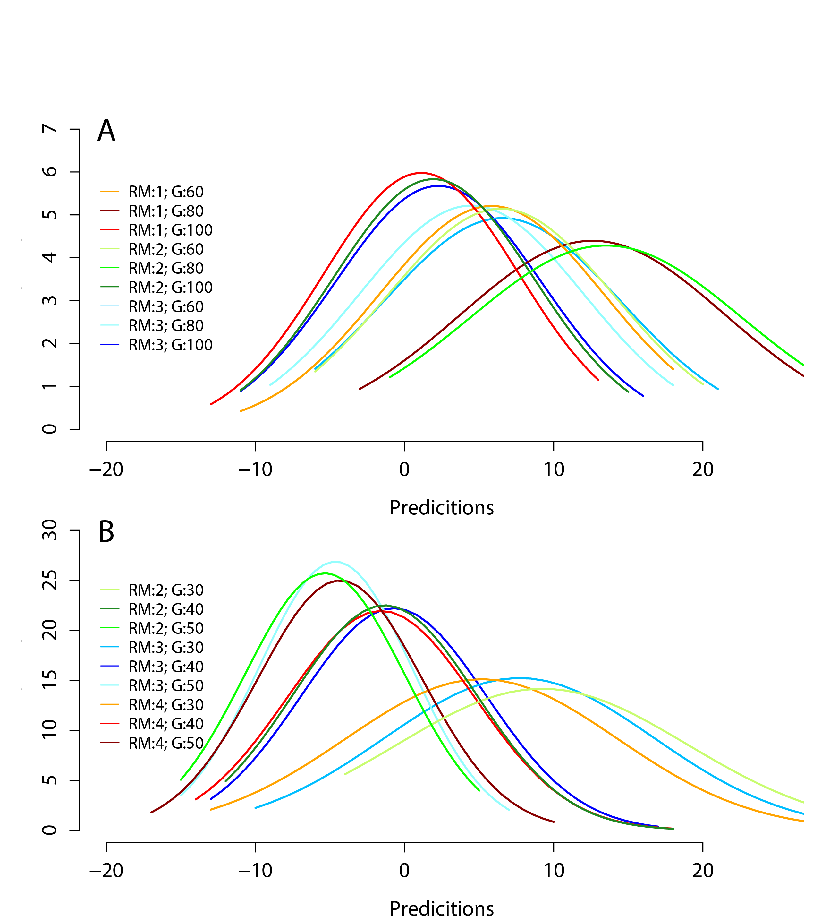

**Figure 2.** **Distributions of differences between predicted stroke rate and actual stroke rate over different running means and gradients.** A) large females diving with accelerometer attached to a harness (N = 49 trials); B) male and female fur seals and sea lions swimming transitionally with accelerometer attached with tape (N = 71 trials).

Boyd, I, Bevan, R, Woakes, A and Butler, P (1999). Heart rate and behavior of fur seals: Implications for measurement of field energetics. *American Journal of Physiology-Heart and Circulatory Physiology* 276(3): H844-H857.

Fahlman, A, Svärd, C, Rosen, D, Wilson, R and Trites, A (2013). Activity as a proxy to estimate metabolic rate and to partition the metabolic cost of diving vs. breathing in pre-and post-fasted Steller sea lions. *Aquatic Biol* 18: 175-184. DOI: 10.3354/ab00500.

Fish, FE (2000). Biomechanics and energetics in aquatic and semiaquatic mammals: Platypus to Whale. *Physiol Biochem Zool* 73(6): 683-698. DOI: 10.1086/318108.

Hocking, DP, Fitzgerald, EM, Salverson, M and Evans, AR (2015). Prey capture and processing behaviors vary with prey size and shape in Australian and subantarctic fur seals. *Mar Mamm Sci* 32(2): 568-587. DOI: 10.1111/mms.12285.

Jeanniard-du-Dot, T, Guinet, C, Arnould, JPY and Trites, AW (2016a). Accelerometers can measure total and activity-specific energy expenditure in free-ranging marine mammals only if linked to time-activity budgets. *Funct Ecol* DOI: 10.1111/1365-2435.12729.

Jeanniard-du-Dot, T, Trites, AW, Arnould, JP, Speakman, JR and Guinet, C (2016b). Flipper strokes can predict energy expenditure and locomotion costs in free-ranging northern and Antarctic fur seals. *Sci Rep* 6: 33912. DOI: 10.1038/srep33912.

Ladds, M, Slip, D and Harcourt, R (2016). Swimming metabolic rates vary by sex and development stage, but not by species, in three species of Australian otariid seals. *J Comp Physiol B* in press DOI: 10.1007/s00360-016-1046-5.

R Core Development Team (2015). R: A language and environment for statistical computing. R version 3.3.1, Available from: <https://www.R-project.org/>.

Rosen, DAS, Hindle, AG, Gerlinsky, CD, Goundie, E, Hastie, GD, Volpov, BL and Trites, AW (2016). Physiological constraints and energetic costs of diving behaviour in marine mammals: a review of studies using trained Steller sea lions diving in the open ocean. *J Comp Physiol B*: 1-22. DOI: 10.1007/s00360-016-1035-8.

Shepard, EL, Wilson, RP, Halsey, LG, Quintana, F, Laich, AG, Gleiss, AC, Liebsch, N, Myers, AE and Norman, B (2008). Derivation of body motion via appropriate smoothing of acceleration data. *Aquatic Biol* 4: 235-241. DOI: 10.3354/ab00104.

Williams, TM, Davis, R, Fuiman, L, Francis, J, Le, B, Horning, M, Calambokidis, J and Croll, D (2000). Sink or swim: strategies for cost-efficient diving by marine mammals. *Science* 288(5463): 133-136. DOI: 10.1126/science.288.5463.133.

Williams, TM, Fuiman, LA, Horning, M and Davis, RW (2004). The cost of foraging by a marine predator, the Weddell seal *Leptonychotes weddellii*: pricing by the stroke. *J Exp Biol* 207(6): 973-982. DOI: 10.1242/jeb.00822.

**Appendix**

|  |  |  |  |  |  |  |  |  |  |  |  |  |  |  |  |  |  |
| --- | --- | --- | --- | --- | --- | --- | --- | --- | --- | --- | --- | --- | --- | --- | --- | --- | --- |
| Running mean | Gradient | mean.x | mean.z | mean.xz | median.x | median.z | median.xz | range.x | range.z | range.xz | sd.x | sd.z | sd.xz | ztest.x | ztest.z | ztest.xz |  |
| 0.4 | 10 | 83.4 | 82.6 | 82.5 | 77 | 78 | 76 | 171 | 175 | 157 | 33.5 | 33.7 | 32.2 | 201.0 | 199.0 | 198.6 |  |
| 20 | 27.2 | 27.8 | 27.7 | 24 | 27 | 27 | 99 | 94 | 94 | 17.3 | 16.2 | 16.2 | 65.6 | 67.0 | 66.7 |  |
| 30 | 9.8 | 10.3 | 9.6 | 7 | 8 | 7 | 76 | 70 | 72 | 13.5 | 12.8 | 13.1 | 23.5 | 24.7 | 23.2 |  |
| 40 | 1.7 | 2.3 | 1.7 | -1 | -1 | -1 | 64 | 58 | 62 | 12.2 | 11.8 | 11.9 | 4.2 | 5.6 | 4.1 |  |
| 50 | -1.5 | -1.5 | -1.9 | -3 | -4 | -4 | 60 | 56 | 57 | 11.7 | 11.6 | 11.5 | -3.6 | -3.6 | -4.6 | * |
| 1 | 10 | 79.6 | 79.5 | 79.7 | 74 | 73 | 72 | 156 | 171 | 160 | 32.1 | 33.1 | 31.4 | 191.8 | 191.5 | 191.9 |  |
| 20 | 31.1 | 29.6 | 29.9 | 28 | 28 | 27 | 111 | 97 | 102 | 19.1 | 16.5 | 17.1 | 74.9 | 71.2 | 71.9 |  |
| 30 | 11.4 | 11.4 | 9.8 | 9 | 11 | 7 | 82 | 74 | 77 | 14.3 | 13.2 | 14.0 | 27.4 | 27.4 | 23.5 |  |
| 40 | 2.6 | 2.9 | 1.6 | 0 | 1 | -1 | 66 | 61 | 67 | 12.5 | 11.2 | 12.7 | 6.4 | 6.9 | 3.8 |  |
| 50 | -0.8 | -1.1 | -1.6 | -3 | -3 | -3 | 58 | 55 | 60 | 11.8 | 11.1 | 11.8 | -1.9 | -2.7 | -4.0 | ** |
|  | 10 | 59.9 | 59.6 | 59.8 | 54 | 55 | 54 | 132 | 126 | 116 | 24.9 | 24.8 | 23.2 | 144.3 | 143.4 | 144.0 |  |
|  | 20 | 31.2 | 28.9 | 29.9 | 28 | 26 | 29 | 103 | 90 | 93 | 18.8 | 16.0 | 16.2 | 75.2 | 69.5 | 71.9 |  |
|  | 30 | 13.4 | 14.2 | 13.1 | 14 | 14 | 13 | 85 | 76 | 83 | 15.0 | 14.4 | 14.3 | 32.4 | 34.2 | 31.6 |  |
|  | 40 | 3.4 | 4.3 | 3.7 | 0 | 2 | 1 | 69 | 63 | 63 | 12.8 | 11.3 | 12.1 | 8.3 | 10.4 | 8.9 |  |
|  | 50 | -0.1 | -0.8 | -0.9 | -3 | -4 | -3 | 56 | 52 | 58 | 11.9 | 10.9 | 11.5 | -0.4 | -1.9 | -2.2 | ** |
|  | 10 | 56.7 | 54.5 | 56.3 | 52 | 50 | 52 | 128 | 105 | 106 | 23.7 | 20.6 | 22.1 | 136.7 | 131.2 | 135.5 |  |
|  | 20 | 24.9 | 21.2 | 23.4 | 24 | 19 | 23 | 102 | 74 | 89 | 16.5 | 13.8 | 15.4 | 59.9 | 51.2 | 56.4 |  |
|  | 30 | 12.0 | 11.1 | 11.5 | 10 | 9 | 10 | 87 | 74 | 77 | 14.4 | 13.1 | 13.4 | 28.9 | 26.7 | 27.8 |  |
|  | 40 | 4.1 | 5.0 | 4.8 | 0 | 3 | 2 | 68 | 64 | 63 | 12.7 | 11.4 | 11.6 | 10.0 | 12.0 | 11.5 |  |
|  | 50 | 0.2 | -0.1 | -0.1 | -2 | -3 | -3 | 59 | 53 | 56 | 11.9 | 11.1 | 11.4 | 0.5 | -0.3 | -0.2 | *** |
|  | 10 | 54.7 | 51.4 | 53.6 | 49 | 49 | 50 | 133 | 97 | 110 | 23.1 | 18.9 | 21.1 | 131.8 | 123.7 | 129.1 |  |
|  | 20 | 22.5 | 17.6 | 20.7 | 22 | 15 | 19 | 104 | 68 | 82 | 16.2 | 12.4 | 14.1 | 54.2 | 42.4 | 49.8 |  |
|  | 30 | 9.5 | 8.1 | 9.1 | 8 | 6 | 6 | 75 | 68 | 71 | 13.4 | 11.9 | 12.8 | 22.9 | 19.4 | 21.9 |  |
|  | 40 | 3.4 | 3.9 | 4.0 | 0 | 1 | 0 | 66 | 60 | 62 | 12.4 | 11.1 | 11.8 | 8.2 | 9.4 | 9.5 |  |
|  | 50 | 0.4 | 0.5 | 0.6 | -2 | -3 | -2 | 61 | 56 | 58 | 11.7 | 11.3 | 11.3 | 1.0 | 1.3 | 1.4 | ** |